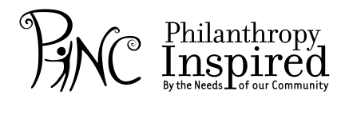

P.O. Box 3413 • Pinedale, CA 93650 • www.pincfresno.org • info@pincfresno.org

2014-2015 Beneficiary Application
Due: October 20, 2014
PINC, Philanthropy Inspired by the Needs of our Community, is a nonprofit organization made up of young women who want to make a positive impact on our community. We aspire to help raise money for other organizations through an annual event held in June. Next year our event will be held in June 2015. We are looking to choose an agency/organization to be our beneficiary for 2015. If you are interested in PINC hosting an event in your honor, please fill out this application in its entirety and return it to PINC no later than October 20, 2014.
Required Information
Agency/Organization Name:

Mailing Address:

Street Address (if different than Mailing):

Contact Number: | Fax Number:
Email: | Website Address:
Executive Director: | Contact Number:
Board Chairman: | Contact Number:
Please describe the Purpose/Mission of your agency/organization:
Please describe the programs/services provided by your agency/organization:
Please describe your geographic areas and client populations served by your agency/organization:
Please identify other fundraising events benefitting your agency/organization: (i.e. golf tournaments, galas)
Please identify other funding sources and/or grants benefitting your agency/organization:
If your agency/organization is chosen, how could you support the event on June 14th?:
How would your agency/organization spend the money raised from our annual event?
We thank you for your commitment in helping our community become better for all individuals. We hope PINC can raise money for your agency/organization to help support your programs and systems already in place. If your agency/organization is chosen as a finalist, we ask that a representative from your agency attend & present at our November monthly meeting on Thursday, Nov 13, 2014.
You will be notified by Monday, November 17, 2014.
Please turn in this application by October 20, 2014 via info@pincfresno.org or through PO Box 3413, Pinedale, CA 93650.

Signature of Authorized Agency/Organization Representative |  | Date

